Lab: Linear-Data-Structures
Write Java code for solving the tasks on the following pages. Code should compile under the Java 8 and above standards you can write and locally test your solution with the Java 13 standard, however Judge will run the submission with Java 10 JRE. Avoid submissions with features included after Java 10 release doing otherwise will result in compile time error.
Any code files that are part of the task are provided as Skeleton. In the beginning import the project skeleton, do not change any of the interfaces or classes provided. You are free to add additional logic in form of methods in both interfaces and implementations you are not allowed to delete or remove any of the code provided. Do not change the names of the files as they are part of the tests logic. Do not change the packages or move any of the files provided inside the skeleton if you have to add new file add it in the same package of usage.
Please follow the exact instructions on uploading the solutions for each task. Submit as .zip archive the files contained inside "...\src\main\java" folder this should work for all tasks regardless of current DS implementation.
In order for the solution to compile the tests successfully the project must have single Main.java file containing single public static void main(String[] args) method even empty one within the Main class.
Some of the problem will have simple Benchmark tests inside the skeleton. You can try to run those with different values and different implementations in order to observe behaviour. However keep in mind that the result comes only as numbers and this data may be misleading in some situations. Also the tests are not started from the command prompt which may influence the accuracy of the results. Those tests are only added as an example of different data structures performance on their common operations.
The Benchmark tool we are using is JMH (Java Microbenchmark Harness) and that is Java harness for building, running, and analyzing, nano/micro/milli/macro benchmarks written in Java and other languages targeting, the JVM.
Additional information can be found here: JMH and also there are other examples over the internet.
Important: when importing the skeleton select import project and then select from maven module, this way any following dependencies will be automatically resolved. The project has NO default version of JDK so after the import you may (depends on some configurations) need to specify the SDK, you can download JDK 13 from HERE.

ArrayList
Your task is to implement the ADS List<E> inside the ArrayList<E> class provided. You can see that this class implements the List<E> interface you have to implement all the methods in order to solve the problem, however you are free to add more methods with any access modifier you want.

Boolean add (E element) – adds an element at the end of the sequence and returns true if successful (always returns true). This method should in addition increase the size of the structure and ensure that there is enough space for the addition to work. If needed you will have to resize the array.

Boolean add (int index, E element) – the only difference from the above one is that now we have a specified index at which to add (insert) an element. This time you have to validate the index then add the element and shift the remaining elements if any from the index + 1 to the right (from the index + 1 to the last index + 1).

E get (int index) – returns the element at the given index and does not remove it from the collection. If the index is invalid throw IndexOutOfBoundsException with a proper message of your chose (the message itself in not subjected to testing).

E set (int index, E element) – sets the element at given index and returns the previously stored at that index element, again you should validate the index and throw IndexOutOfBoundsException if the validation fails.

E remove (int index) – removes the element at specified index and returns it – again the same validation, here you should already have some way to reuse the index validation.

Int size () – returns the number of elements.

Int indexOf (E element) – returns the index of an element if the element is not present in the structure then return -1 as invalid array index.

Boolean contains (E element) – returns true or false if the element is present inside the structure.

Boolean isEmpty () – returns if there are elements stored or no.

Solution:

Boolean add (E element):
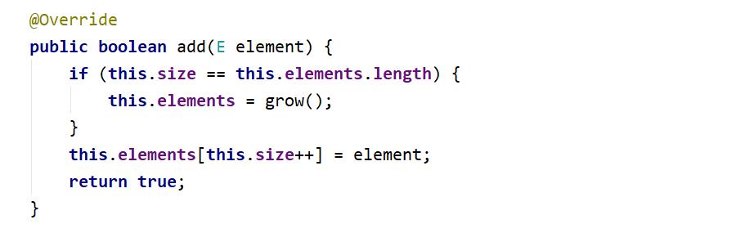

The – grow () helper method:
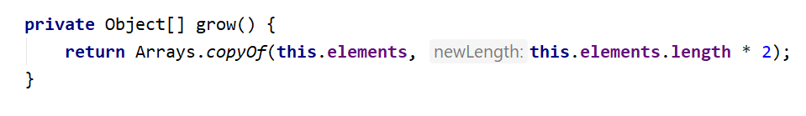

Boolean add (int index, E element):
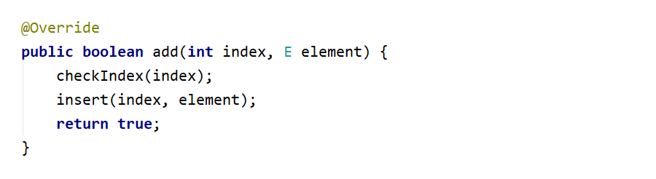

The insert (int index, E element) method:
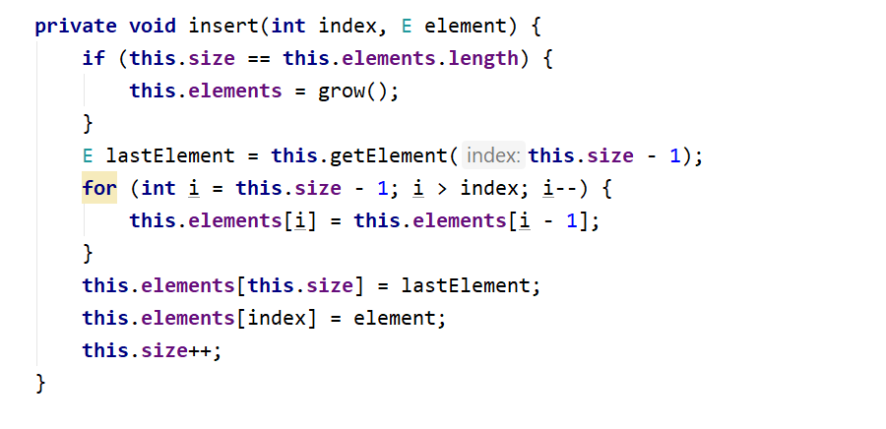

E get (int index):

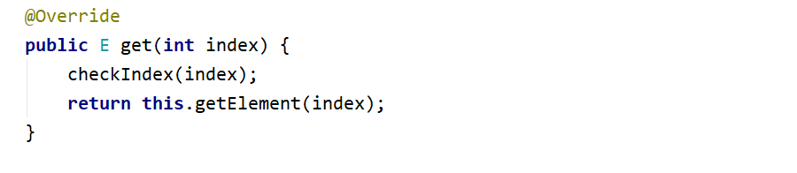

E set (int index, E element):

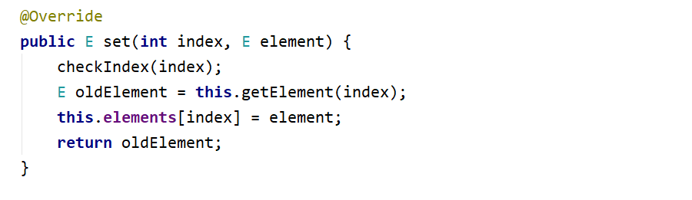

E remove (int index):
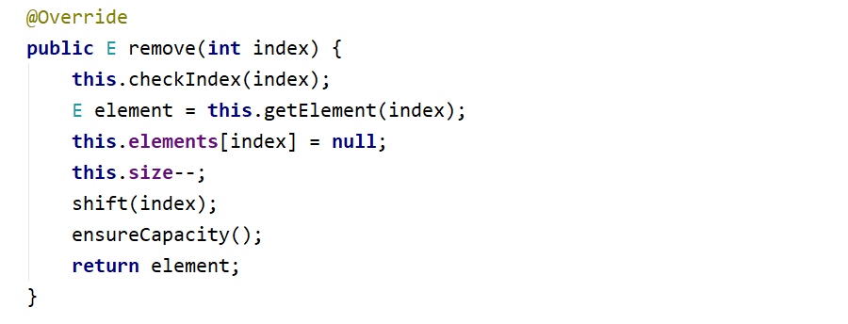

Take a look at those additional helper methods, you can reuse them whenever needed: First ensure capacity of the array if we have less than one third of the elements we can shrink the array.

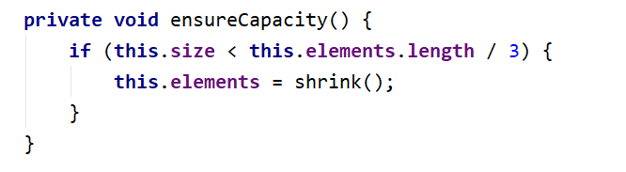

The shrink method, looks a lot like grow with one major difference – we reduce the space:
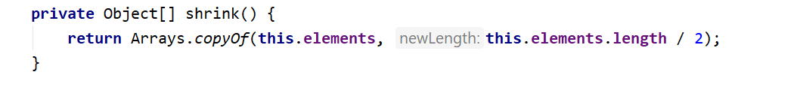

And last but not least the check index method, feel free to modify the message.
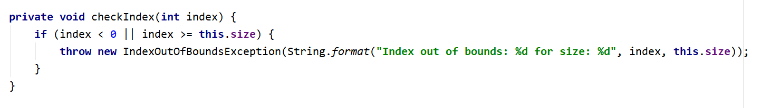

Iterator<E>
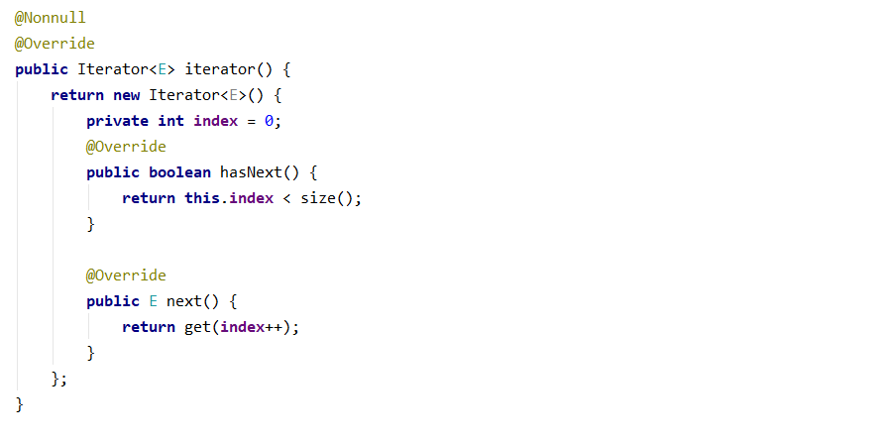

All of the other methods are really easy and straightforward to be implemented so you won't need any help. If it doesn't work the first time simply try different approach.

Stack

Your task is to implement the ADS AbstractStack<E> inside the Stack<E> class provided. You have to implement all the methods in order to solve the problem, however you are free to add more methods with any access modifier you want.

Push (E element) – adds an element at the top of the stack and increases the size.

E pop () – removes an element at the current top of the stack and returns it if there is element if the stack is empty throw IllegalStateException with appropriate message.

E peek () – return the element at the current top of the stack if the stack is empty throw IllegalStateException with appropriate message.

Int size () – returns the number of elements inside the stack.

Boolean isEmpty () – returns if the stack contains any elements or not.

Solution:

Push (E element)
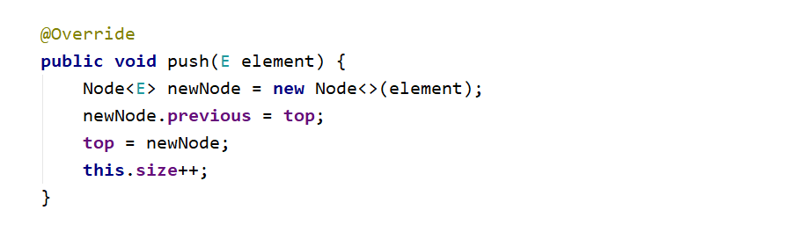

E pop ()
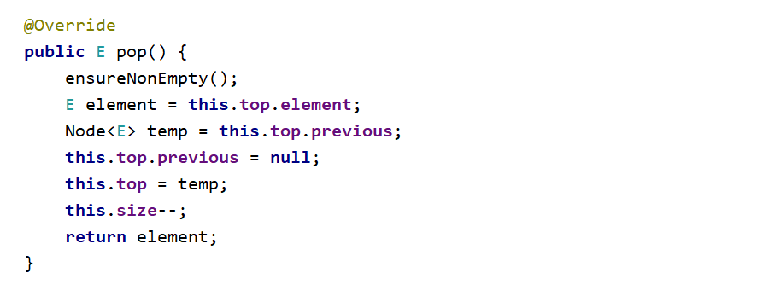

E peek ()
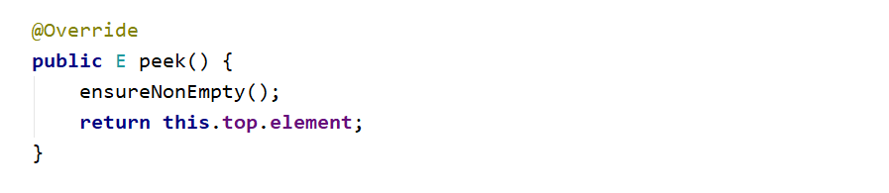

Iterator<E>
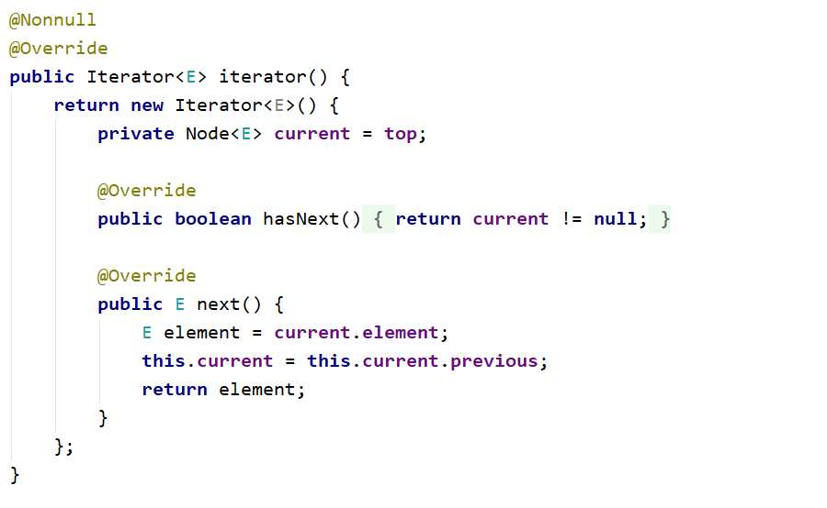
All of the other methods are really easy and straightforward to be implemented. If it doesn't work the first time simply try different approach.

Queue
Your task is to implement the ADS AbstractQueue<E> inside the Queue<E> class provided. You have to implement all the methods in order to solve the problem, however you are free to add more methods with any access modifier you want.
- Offer (E element) – adds an element at the end of the queue and increases the size.

E poll () – removes and returns the first element at the queue also decreases the size and performs a check if this method is called upon empty collection if so throw IllegalStateException with message of your chose the message itself will not be tested.

E peek () – return the element at the current front of the queue if the collection is empty throw IllegalStateException with appropriate message.

Int size () – returns the number of elements inside the stack.

Boolean isEmpty () – returns if the stack contains any elements or not.

Solution:
As you can see a lot of the operations described above are a lot like those we did on the Stack problem so think how you can reuse and modify those. Now you can see slightly different way of adding the elements in the stack implementation we had pointer to the top element here we have to the first pointer so you need to find the last element so you can offer the new node. The only specific problem here is the poll () method:
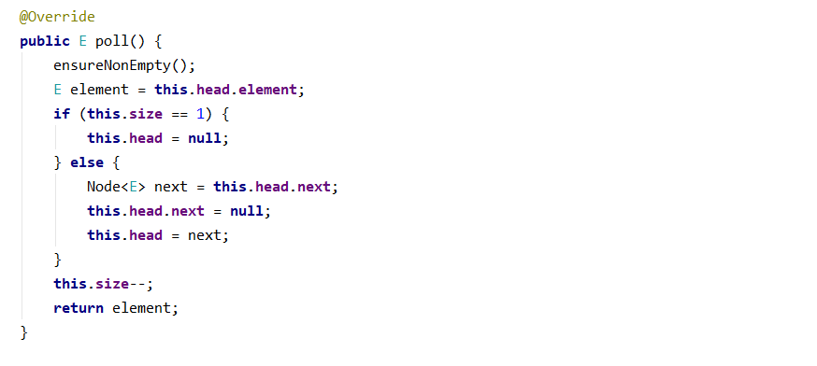

SinglyLinkedList
Your task is to implement the ADS List<E> inside the ArrayList<E> class provided. You can see that this class implements the List<E> interface you have to implement all the methods in order to solve the problem, however you are free to add more methods with any access modifier you want.

AddFirst (E element) – adds an element in front of the collection and increases the size.

AddLast (E element) – adds an element after the last element of the collection and increases the size.

E removeFirst () – removes and returns the first element of the collection if there is such if no then throw IllegalStateException with appropriate message.

E removeLast () – removes and returns the last element of the collection if there is such if no then throw IllegalStateException with appropriate message.

E getFirst () – returns but does not remove the first element of the collection if there is such if no then throw IllegalStateException with appropriate message.

E getLast () – returns but does not remove the last element of the collection if there is such if no then throw IllegalStateException with appropriate message.

Int size () – returns the number of elements inside the collection.

Boolean isEmpty () – returns if the collection contains any elements or not.

Solution:
Here comes the tricky part, all of the operations above are really alike the previous ones you have implemented combined and modified of course. But in really small and simple matters so try to solve those on your own. Good Luck! And remember if something gets too complicated or unclear and does not work you can always start again by choosing a different approach.

"The presence of those seeking the truth is infinitely to be preferred to the presence of those who think they've found it." ― Terry Pratchett, Monstrous Regiment

